TOPIC 1
LO: To understand the legacy of the Ancient Greeks on langauge
Find up to 3 words containing these Greek roots – some will be at the beginning of words but some won’t. Use these examples, a dictionary or Google to help you explain what the Greek roots mean. The first one has been done for you.

Greek Root | Definition | Examples
auto | self | automatic, automobile
bio
chron
hydr
hypo
micro
mono
photo
tele
therm
phobia
logy
scope
gram
graph

TOPIC 2
LO: To research the legacy of famous Ancient Greek philosophers, scientists and mathematicians

Research one of these famous Greek people: Plato, Archimedes or Pythagoras.
Choose how to present your information, e.g. poster, leaflet, PowerPoint etc. Be as creative as you like!
Use these key questions to help you find relevant information.
Plato
- When and where was he born?
- What was he famous for?
- What were his family like?
- What did he do when he was young?
- Who did he learn from?
- What was one of his goals?
- When did he die?
Archimedes
- When was he born?
- What did his father do?
- Where did he go to study?
- What different machines did he invent? What were they like / used for?
- Why did he shout Eureka?
- What did he learn about floating?
- How did he die? When?
Pythagoras
- Who was he?
- When did he live?
- Where did he live most of his life?
- What is he famous for proving?
- What were some of the things that the people who followed him did / believed?

Here are some websites to use for your research.

Plato
http://www.historyforkids.org/learn/greeks/philosophy/plato.htm
http://www.philosophyslam.org/plato.html
http://www.kidspast.com/world-history/0072-plato.php

Archimedes
http://www.historyforkids.org/learn/greeks/science/math/archimedes.htm
http://www.bbc.co.uk/history/historic_figures/archimedes.shtml
http://easyscienceforkids.com/all-about-archimedes/

Pythagoras
http://www.historyforkids.org/learn/greeks/science/math/pythagoras.htm
http://www.bbc.co.uk/history/historic_figures/pythagoras.shtml
http://www.famousscientists.org/pythagoras/

If you don’t have access to the Internet, here is some information to use for your research.
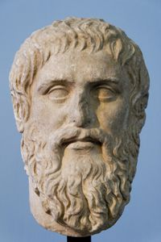
Plato
Roman copy of a portrait bust by Silanion for the Academia in Athens (c. 370 BC)
Full name | Plato
Born | 428/427 or 424/423 BC  Athens, Greece
Died | 348/347 BC (age c. 80)  Athens, Greece
Era | Ancient philosophy
Region | Western philosophy
Plato was one of the greatest classical Greek philosophers. He lived from 427 BC to 348 BC. He was a student of Socrates and the teacher of Aristotle. Plato wrote about many ideas in philosophy that are still talked about today. One modern philosopher, (Alfred North Whitehead), said that all philosophy since Plato has just been comments on his works.
Plato wrote his books in the form of dialogues—people talking about ideas, and sometimes disagreeing about them. This makes Plato's books more interesting to read.
Socrates is usually the main person in Plato's dialogues. Usually, Socrates talks with people about their ideas, and tries to see if they believe anything that is illogical. Other people in the stories often become angry with Socrates because of this. People who study Plato argue about whether Socrates really said the same things that Plato makes him say, or whether Plato just used Socrates as a character, to make the ideas he was talking about seem more important.
Plato opposed the rhetorics of sophism and insisted true justice and equality in his work "Gorgias" and immortality of soul in "Phaedo".
One of Plato's most famous works is The Republic (In Greek, Politeia, or 'city'). In that work, he describes Socrates's vision of an "ideal" state. The method of questioning in this dialogue, called the Socratic method, is as important as the content. The Republic contains ideas of Socrates: "Socrates said it, Plato wrote it."
The Laws is Plato's longest dialogue and probably his last.
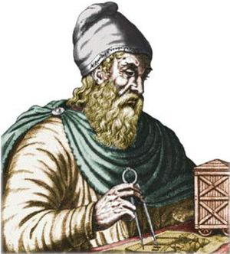

Archimedes
Archimedes (287 BC–212 BC) was a Greek scientist. He was an inventor, an astronomer, and a mathematician. He was born in the town of Syracuse in Sicily.
His father was Phidias, an astronomer, and he may have been in the family of a king of Syracuse. Syracuse was a rich Greek city, on the sea shore in Sicily. When Archimedes was about ten years old, he left Syracuse to study in Alexandria, Egypt. He was in the school of Euclid, a famous mathematician. Not much is known about the personal life of Archimedes, for example, whether he was married or if he had children. He died during a Roman invasion.

Spherical geometry
On the Sphere and Cylinder is a work that was published by Archimedes in two volumes in about 225 BC. On the sphere, he showed that the surface area is four times the area of its great circle.

Archimedes the scientist
Archimedes is also well known for being the first person to understand statics, which is a part of applied mathematics. It has to do with loads that do not move, for example in buildings or bridges. He also understood and wrote about what happens when things float in liquids, which is called buoyancy.
Archimedes' principle: the weight of water displaced by an object equals the amount of buoyancy it gets. It has practical uses. It can be used to measure the density of an object, and hence whether or not it is made of gold.
The story of the golden crown does not appear in the surviving works of Archimedes. Archimedes may have got a solution known in hydrostatics as Archimedes' principle, which he describes in his treatise On Floating Bodies. This principle states that a body immersed in a fluid experiences a buoyant force equal to the weight of the fluid it displaces. Using this principle, it would have been possible to compare the density of the golden crown to that of solid gold by balancing the crown on a scale with a gold reference sample, then immersing the apparatus in water. The difference in density between the two samples would cause the scale to tip accordingly. Galileo considered it "probable that this method is the same that Archimedes followed, since, besides being very accurate, it is based on demonstrations found by Archimedes himself".

Archimedes, the inventor and engineer
Archimedes is also famous as an inventor because he made new tools and machines. For example, he made a machine to lift water that could be used by farmers to bring water to their crops. This is called Archimedes' screw.
Archimedes probably also invented a machine to measure distance, an odometer. A cart was built with wheels that turned four hundred times in one mile. A pin on the wheel would hit a 400-tooth gear, so it turned once for every mile. This gear would then make a small stone fall into a cup. At the end of a journey one could count the number of stones in the cup to find the distance.
Archimedes also made a system which one person could pull a large ship with just one rope. This was called the compound pulley. This is an important machine even today, as it helps people in everyday life, although the versions we now use are much more complicated. They still work by the same principle, though.

Archimedes at war
Archimedes also invented or made many machines used in war, for example he made better catapults. This was during the Punic Wars, which were between Rome in what is now Italy and the city of Carthage in what is now North Africa. For many years he helped stop the Roman army from attacking Syracuse, his city. One war machine was called the "claw of Archimedes", or the "iron hand". It was used to defend the city from attacks by ships. Ancient writers said that it was a kind of crane with a hook that lifted ships out of the water and caused their destruction.
Another story about Archimedes is that he burned Roman ships from far away using many mirrors and the light from the sun. This is perhaps possible, but it is perhaps more likely that this was done with flaming missiles from a catapult.
After many years the Roman army took the city of Syracuse. One of the soldiers killed Archimedes, who was then an old man. The soldiers had perhaps been told to catch Archimedes alive, so it may have been a mistake. The story is that Archimedes was killed while drawing a mathematical diagram in the sand. He was so busy with his drawing that he did not see the soldier behind him. His famous last words were, “Don’t disturb my circles!”

Tributes to Archimedes
Archimedes is thought to be so important as a mathematician that scientists have honoured him:
- A large hole or crater on the moon is named after Archimedes.
- Some mountains on the moon are called the Montes Archimedes.

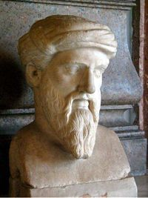
Pythagoras
Full name | Pythagoras
Born | c. 570 BC  Samos
Died | c. 495 BC (aged around 75)  either Croton or Metapontum
Era | Ancient Greek philosophy
Pythagoras of Samos was a famous Greek mathematician and philosopher (c. 570 – c. 495 BC). He is known best for the proof of the important Pythagorean theorem, which is about right triangles. He started a group of mathematicians, called the Pythagoreans, who worshiped numbers and lived like monks. He was an influence for Plato.
He had a great impact on mathematics, theory of music and astronomy. His theories are still used in mathematics today. He was one of the greatest thinkers of his time.
Pythagoras was born in Samos, a little island off the western coast of Asia Minor. There is not much information about his life. He was said to have had a good childhood. Growing up with two or three brothers, he was well educated. He did not agree with the government and their schooling, so he moved to Croton and set up his own cult (little society) of followers under his rule. His followers did not have any personal possessions, and they were all vegetarians. Pythagoras taught them all, and they had to obey strict rules.
Some say he was the first person to use the term philosophy. Since he worked very closely with his group, the Pythagoreans, it is sometimes hard to tell his works from those of his followers.
Religion was important to the Pythagoreans. They swore their oaths by "1+2+3+4" (which equals 10). They also believed the soul is immortal and goes through a cycle of rebirths until it can become pure. They believed that these souls were in both animal and plant life.

His beliefs
Pythagoras' most important belief was that the physical world was mathematical and that numbers were the real reality.
- that at its deepest level, reality is mathematical in nature,
- that philosophy can be used for spiritual purification,
- that the soul can rise to union with the divine,
- that certain symbols have a mystical significance, and
- that all brothers of the order should observe strict loyalty and secrecy.

Pythagorean theorem
Pythagoras is most famous for his theorem to do with right triangles. He said that the length of the longest side of the right angled triangle called the hypotenuse (C) squared would equal the area of the other sides squared. And so (a x a) + (b x b) = (c x c) was born. There are many different proofs for this Pythagorean theorem.

ICT – Scratch
If you are able, have a go at following the separate instructions to code a musical instrument and program your own animation.

Art – Cubism
Cubism began in France in 1907. Pablo Picasso and George Braque began painting figures that were made up of cubes, spheres, cylinders, cones, and other geometric shapes. The paintings looked like someone had cut them up and glued them back together!
Cubist artists such as Picasso did not use perspective in their paintings. Instead they showed lots of different views of the object being painted at once!
Here are some examples.
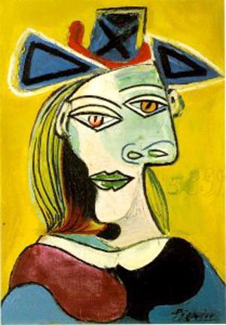
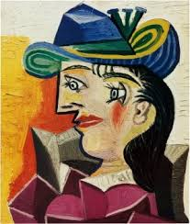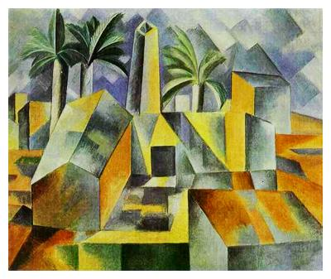
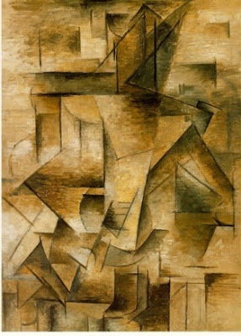
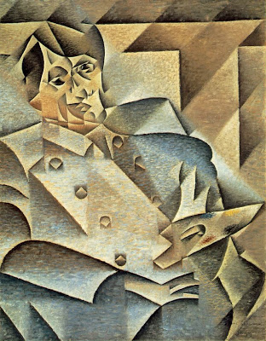

Follow these instructions to create your own cubism portrait!
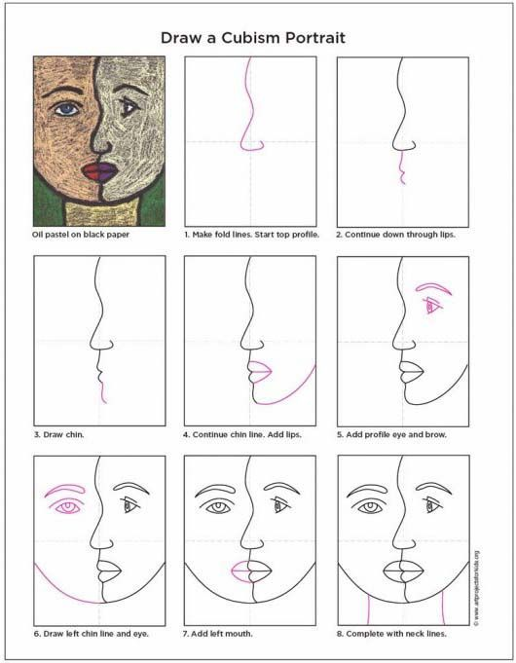

RE – The Easter Story
Here is a version of the Easter story. Read the story to remind you of the events of Easter then create your own comic strip to represent the events. You can use one of the templates below to help you or you can create your own.
Jerusalem bustled. The inns and guest houses for miles around were full to bursting, and tents crowded the slopes below the city.
In the shadow of the Golden Gate, we sampled fish and fruit. Merchants sold bleating sheep and cooing doves; pilgrims exchanged their money for Tyrian coin and haggled over the price of prayer shawls and shofars. The market was so busy that it was impossible to walk without being jabbed by elbows or trampled by sandals.
That’s when we overheard the gossip.
“The King of the Jews is here! Move aside!”
Gabbling and pushing, the crowd drew back. Some laid palm fronds on the dusty road. Whoever was coming, he had to be really important.
Then, we saw him: a man riding on a donkey. He didn’t look rich, powerful or special in any way, but all around, the crowd began to shout, “Blessed is the king! Peace in heaven!”
“Who is he?” said a voice, and answers flew from every side.
“He’s a teacher!”
“No, he’s a madman!”.
“Wherever he goes, he cures the sick, the deaf and the blind.”
“Wherever he goes, he angers people.”
“He’s the Messiah – the Son of God.”
“Look, he’s going into the temple. Let’s hear what he has to say.”
Some doubted him, some were devoted to him, but everyone swept eagerly into the temple. Little did anyone know that at that very moment, a few streets away, a plot was brewing – a plot against Jesus.
While the crowd heard Jesus preach, the High Priest Caiaphas met with all the elders of the Jewish temple. They had gathered at his palace to discuss how they could arrest Jesus – arrest him and kill him.
“That young upstart! Who does he think he is?”
“He says that he’s the Son of God!”
“He must be dealt with before he turns the people against us.”
Caiaphas called for order. “The people are listening to this man, and soon, they will stop listening to us. I have been High Priest too long to let this commoner steal my power. If we condemn Jesus publicly, the crowd will turn on him. But first, we must find him when he is alone.”
That’s when a man arrived at their gathering. His name was Judas Iscariot, and he was one of Jesus’ disciples.
“What will you give me if I agree to betray Jesus?” asked Judas
Caiaphas counted out thirty silver pieces into Judas’ palm.
Soon afterwards, Jesus sat with his followers in a house in the city as they ate their Passover meal. He shared bread and wine with the disciples, saying, “This bread is my body and this wine is my blood.”
Then, he looked around at the twelve men who travelled with him wherever he went and said, “Soon, you will all leave me.”
Shocked, the disciples insisted that it wasn’t so. None was surer than Peter.
“My Lord, I never would!”
“Peter,” said Jesus kindly, “you will deny me three times before the rooster crows for morning.” As Peter sat speechless, Jesus continued. “What’s more, one person here will be my betrayer. This is the last supper that I will share with you, for tomorrow I will die.”
The disciples fell silent.
Then, Jesus said, “But after that, I shall rise and go north, to Galilee. Meet me there.”
Just imagine the looks on the disciples’ faces then!
After supper, Jesus went to the Garden of Gethsemane to pray. That night, the air of Jerusalem hung still and heavy with the scent of almond blossom. The olive trees stood guard like gnarled sentinels.
Though he had seemed calm at supper, Jesus was troubled.
“Please, watch over me,” he told his companions as he knelt to pray.
Some say he prayed so earnestly that an angel appeared to him and blessed him with strength for the trials ahead. He prayed so feverishly that sweat poured down his face. He prayed for so long that when he returned to his disciples, they were sleeping.
“Wake up!” he commanded. But at that moment, the darkness of evening was dispersed by golden light, which flooded into the garden and bounded from tree to tree.
Priests and soldiers crowded into the garden, waving torches and clubs. As Jesus turned to face the light, Judas stepped forwards from among them and greeted him with a kiss on the cheek.
This was the signal that the soldiers had been waiting for. With a roar, they surged forward, seized Jesus and marched him from the garden.
As Jesus was led away, the disciples fled into the darkness.
The soldiers led Jesus to the palace of Caiaphas. Peter followed at a distance, desperate for news. He trembled from head to foot.
As Peter waited in the courtyard to hear what the elders would accuse Jesus of, a servant girl noticed him.
“You’re one of Jesus’ men, aren’t you?” she asked.
Peter jumped. “I don’t know what you’re talking about!” he said at once.
“Yes, you are,” said another girl. “I can tell by your accent.”
“I don’t know the man!”
“You do, you do – I saw you together,” said a third.
“No, no!” cried Peter.
At that moment, the rooster crowed to signal morning, and Peter remembered what Jesus had foretold. As he ran from the courtyard, shame burned in his chest.
But all that, I only learnt later. The first I heard of it was in the morning, outside the governor’s palace. The Roman governor’s name was Pontius Pilate and that morning, he brought Jesus and another prisoner before the crowd. The priests had accused him of blasphemy; the governor did not like the people calling him ‘King’. Neither the priests nor Pilate had found enough evidence of Jesus’ wrongdoings to sentence him to death, so Pilate had decided to let the people decide his fate.
“Since it is Passover, you may choose one prisoner to go free,” Pilate announced. “The first is Barabbas: a rebel and a murderer. The other is Jesus, whom you call ‘King of the Jews’.”
At that, the crowd near the steps began to chant: “Crucify him! Crucify him!”
Jesus’ face didn’t change. He wasn’t shocked or angry; it was as if he had expected this.
Pilate asked the crowd, “What crime is he guilty of?” Undeterred, the crowd chanted louder and louder.
At last, Pilate shrugged. “Fine. Barabbas will be freed and Jesus will be crucified. I wash my hands of this.”
On Pilate’s orders, Jesus was marched away and dragged into the palace. We heard Jesus’ cries as they beat him.
Soon, the soldiers began to laugh. “Hail, King of the Jews!” they mocked. “Hail! Hail!”
When they pushed Jesus outside, we saw what the soldiers had done. He was dressed in a richly-coloured robe, like a king. On his head rested a crown of thorns.
The soldiers spat at him, struck him and stripped him of his kingly robe, but the crown remained, its cruel thorns digging into Jesus’ flesh.
So, Jesus was led to Golgotha – ‘the Place of the Skull’. Some say that he carried his own cross, and others say that the soldiers made a man called Simon of Cyrene carry it most of the way.
Jesus was one of three to be crucified that day. Everyone watched as the soldiers offered him bitter wine and as he refused it. Everyone held their breath as the soldiers divided up Jesus’ clothes.
Then, the soldiers nailed Jesus to the cross by his hands and feet, and hoisted him aloft. Above him hung a sign:
This is Jesus, King of the Jews.
We waited.
At noon, the sky turned black. And still, we waited.
At three, Jesus cried out with a sound that seemed to shatter the sky.
The earth shook.
Quaking, the centurion who guarded Jesus cried out,
“Surely, he was the Son of God!”
A rich man named Joseph of Arimathea asked the governor for Jesus’ body. With Pilate’s permission, he wrapped Jesus in linen cloth and carried him away.
Joseph had a tomb close by, hewn from rock. He placed Jesus inside. Nearby, stood the women who followed Jesus; among them was Mary Magdalene, who had travelled with Jesus through Galilee ever since Jesus had healed her. The women watched sombrely as Joseph’s servant rolled a huge stone across the entrance of the tomb.
Jesus had been betrayed and denied, and now he lay in a tomb – but that wasn’t the end of the story...
The next day was the Sabbath: a day of rest in the midst of festivities. The following day – the third day after Jesus’ death – something very strange happened.
That morning, as the sun rose, Mary Magdalene and the other women returned to the tomb with spices to anoint Jesus’ body. The crunching of their feet broke the stillness of the morning and the air was threaded with the scent of blossom.
As they entered the garden, a sight greeted the women that made them stop in their tracks...
the stone covering the tomb’s entrance had been rolled away.
Nervously, the women stepped closer.
Inside the tomb, they saw an angel with a face like lightning and robes as white as snow.
“Don’t be afraid,” said the angel. “Jesus is not here – he has risen, as he said he would.”
The women rushed from the tomb, full of joy, to tell the disciples what they had seen and from there, the news spread all over Jerusalem.
Some say that Jesus appeared to the women right there, in the garden. Some say that he met his disciples on the road to Emmaus, or on a mountain, or at a feast in Galilee. They all say that what he prophesied was fulfilled: that after he was crucified, he rose from the dead. But all that was many years ago now.

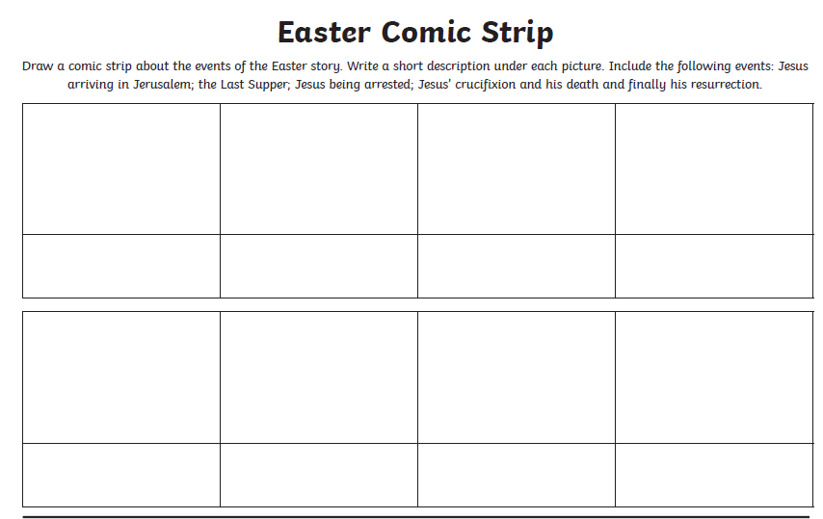

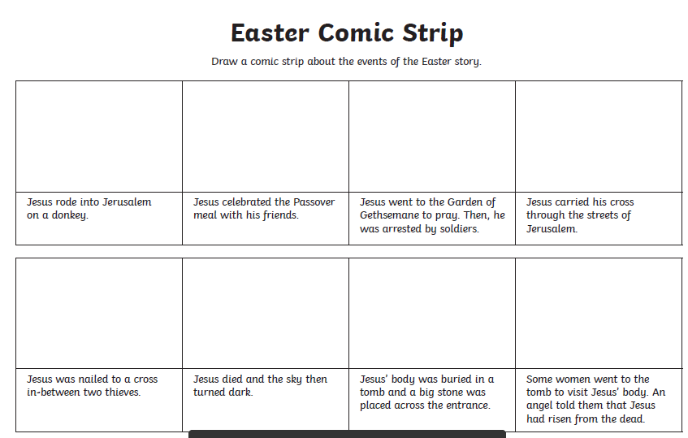

Science – Forces
Use the information below to answer the questions about Sir Isaac Newton.
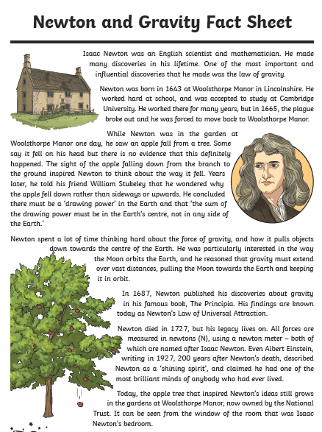
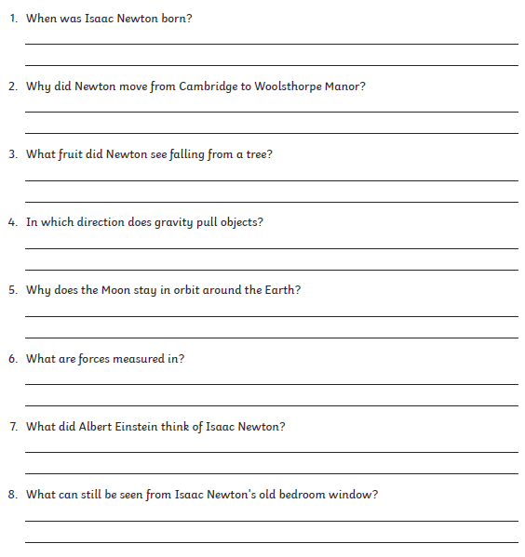

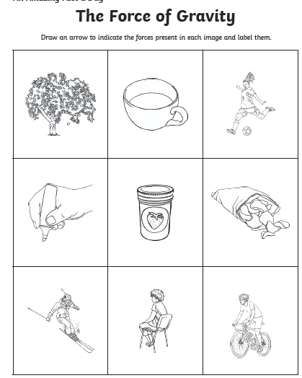
Use these words to help you label the forces:
Gravity
Friction
Air resistance

