Writing Explanations
LO: To identify the features of explanation texts
Can you identify the features below in the model text? (The Teacher Pleaser) When you find an example, record it in the table below.

Feature | Example
A title
An introduction
A rhetorical question to hook the reader
Causal conjunctions and adverbials (e.g. because, which etc.)
Topic sentence to introduce the text
Time conjunctions and adverbials
Technical language
Descriptive language
Diagrams or illustrations with captions
A conclusion which summarises the key points

The ‘Teacher Pleaser’ Machine
Do you suffer from a grumpy teacher? If so, use the 'Teacher-Pleaser' machine and soon your teacher will become the jolliest person in school.

To start the machine running, you have to wind up the clockwork handle. This provides enough energy to turn the large wheel which causes the apple dispenser to work. As the wheel spins, this also causes the tea mug to heat up so that a fresh, warm cup of tea (all teachers’ favourite drink!) can be served.

If the wheel begins to slow down, you must turn the handle again. As a result, the clockwork machinery will speed up the wheel. To turn on one of the best features of the 'Teacher-Pleaser’, press the red button on the top of the machine. This will result in starting up the pencil-sharpener. Therefore - in 30 seconds - you can sharpen every pencil!

Furthermore, if you press the green button, a spinning brush appears which will sweep up and recycle any pieces of paper, so that your class can be clean and tidy. Finally, there is an in-built calendar which alerts you to your teacher's birthday so that you can remember to buy a present.

Use one of these amazing machines because it will keep your teacher happy. The more you use it, the more everyone’s school life will be a breeze!

LO: To answer questions about an explanation text
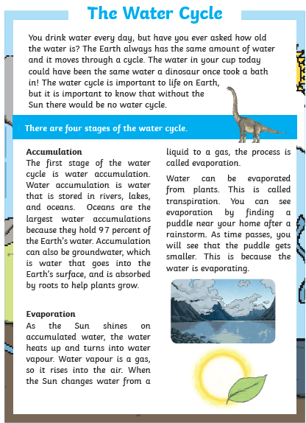

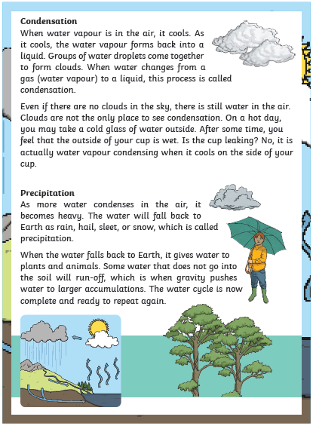

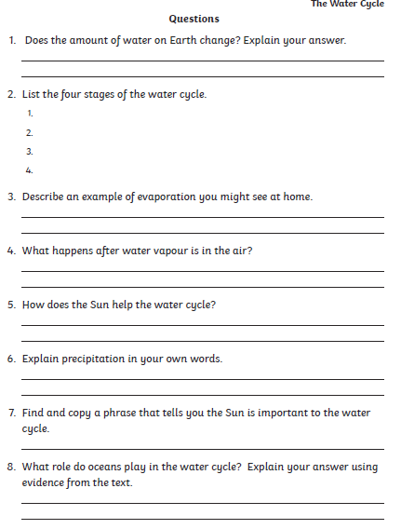

LO: To use causal conjunctions
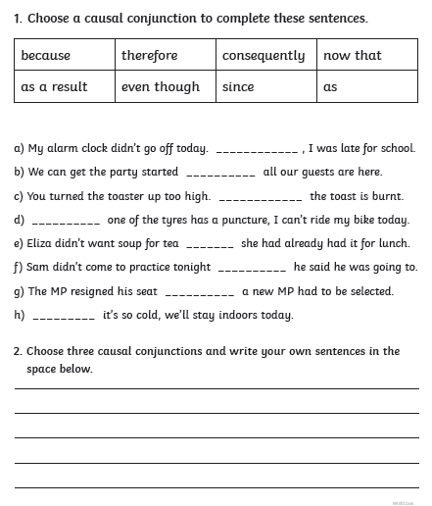

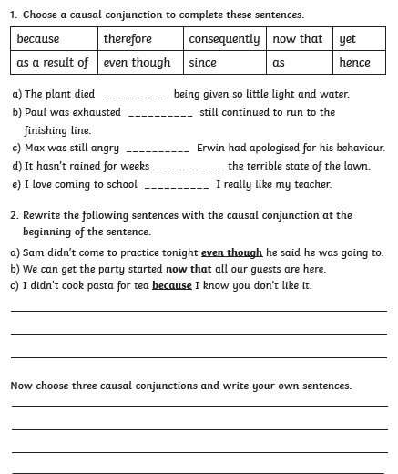

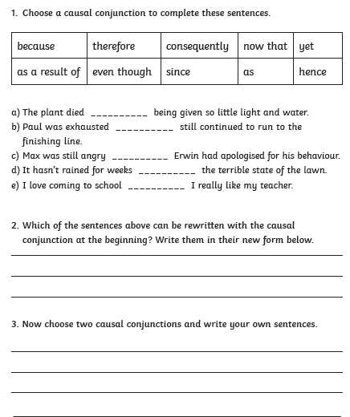

LO: To use causal conjunctions and adverbials in an explanation

Use the words below to help you complete the explanation of why Anthony was often in detention.
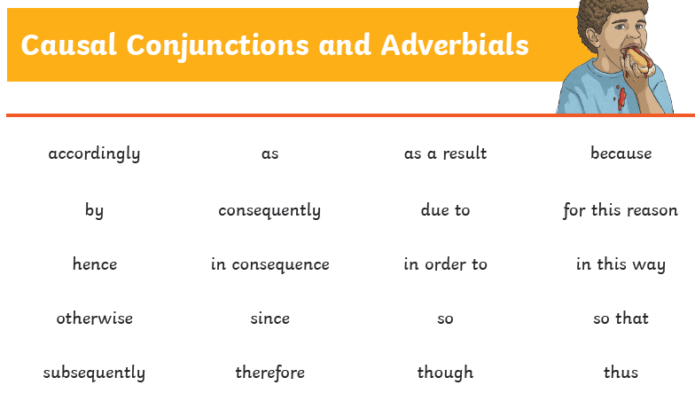

excuses
reasons

Why Anthony was often in detention
Anthony found it impossible to stick to deadlines and, _______________________, he was always late for school. His _____________ were many and varied. Sometimes he said it was _____________ his alarm failed to go off or that ______________ his sister refused to come out of the bathroom. Another favourite ____________ was that he was finishing his homework or walking the dog. ___________________ he was often in detention.

Continue this explanation with 3 more reasons of your own.
LO: To identify adverbials to link ideas and paragraphs
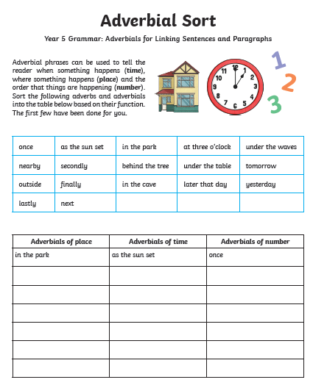

LO: To use adverbials to link ideas and paragraphs
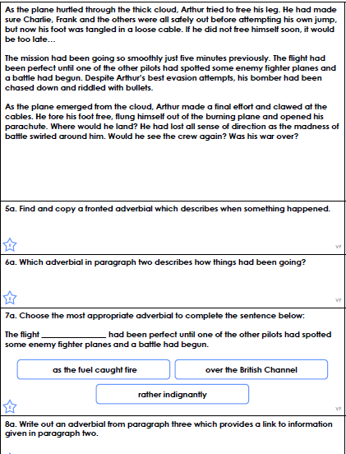

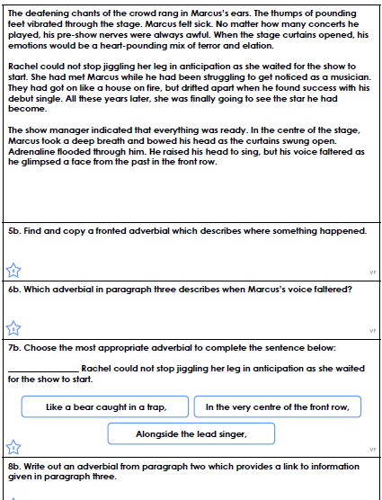
LO: To plan an explanation text
Use the model text (The Teacher Pleaser) at the start and one of these planning frames to help you plan an explanation of your own machine to help someone, e.g. the parent pleaser.

The ___________________ Pleaser Machine

Introduction -  Who needs it and why | Do you suffer from a
How to start it and what happens | To start the machine
What to do if it starts to break | If the ______ begins to
Special feature | Furthermore, if you press the
Conclusion  How it will change your life | Use one of these
The ___________________ Pleaser Machine
Do you suffer from a

If so, use the

and your

will become

To start the machine

This provides

which causes

As the

this causes

so that
If the ______ begins to

As a result

To turn on one of the best

features of the
Therefore
Furthermore, if you press the

which will

so that
Use one of these

because

The more you use it
LO: To write an explanation text
Use the word bank of causal vocabulary and list of features to help you write the explanation of your new machine.

Feature
A title
An introduction
A rhetorical question to hook the reader
Causal conjunctions and adverbials (e.g. because, which etc.)
Topic sentence to introduce the text
Time conjunctions and adverbials
Technical language
Descriptive language
Diagrams or illustrations with captions
A conclusion which summarises the key points

Remember to proof-read your work once you have finished!

The ________________________ Pleaser Machine
LO: To use commas to avoid ambiguity
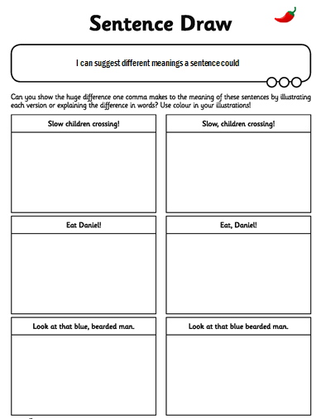

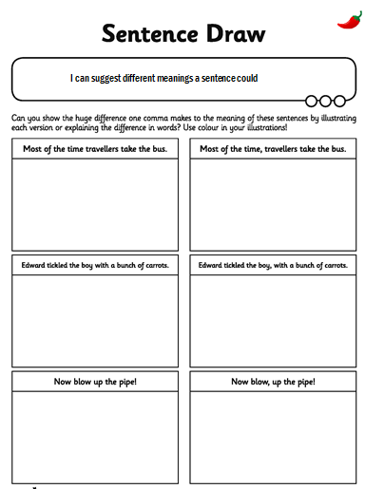

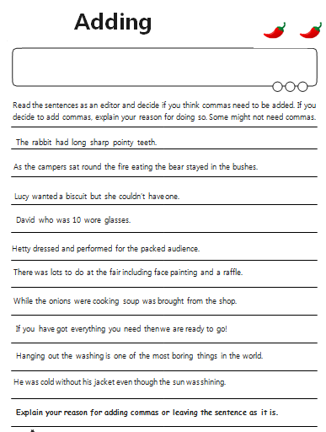

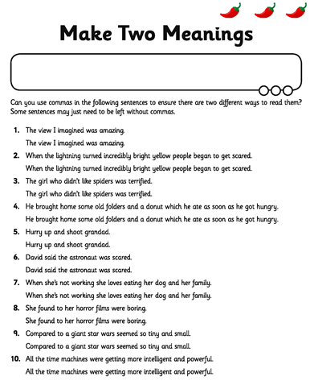

To change nouns and adjectives into verbs using the suffixes –ate, -ise or –ify
