Queen Eleanor’s C of E Junior School




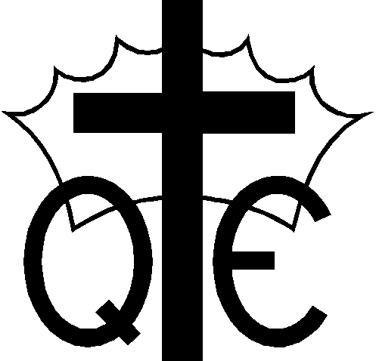


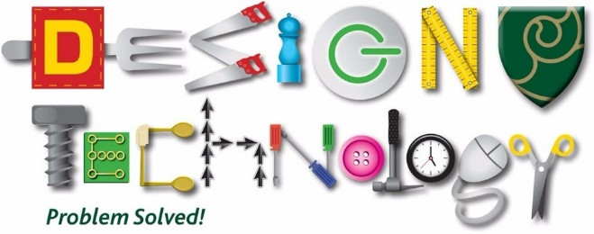

Key Assessment Criteria for Foundation Subjects at QE

Key Assessment Criteria Being a Geographer
What the National Curriculum requires in geography at KS2
Locational knowledge
•Locate the world’s countries, using maps to focus on Europe (including the location of Russia) and North and South America, concentrating on their environmental regions, key physical and human characteristics, countries, and major cities
•Name and locate counties and cities of the United Kingdom, geographical regions and their identifying human and physical characteristics, key topographical features (including hills, mountains, coasts and rivers), and land-use patterns; and understand how some of these aspects have changed over time
•Identify the position and significance of latitude, longitude, Equator, Northern Hemisphere, Southern Hemisphere, the Tropics of Cancer and Capricorn, Arctic and Antarctic Circle, the Prime/Greenwich Meridian and time zones (including day and night)
Place knowledge
•Understand geographical similarities and differences through the study of human and physical geography of a region of the United Kingdom, a region in a European country, and a region within North or South America.
Human and physical geography
•Describe and understand key aspects of:
Physical geography, including: climate zones, biomes and vegetation belts, rivers, mountains, volcanoes and earthquakes, and the water cycle
Human geography, including: types of settlement and land use, economic activity including trade links, and the distribution of natural resources including energy, food, minerals and water.
Geographical skills and fieldwork
•Use maps, atlases, globes and digital/computer mapping to locate countries and describe features studied
•Use the eight points of a compass, four and six-figure grid references, symbols and key (including the use of Ordnance Survey maps) to build their knowledge of the United Kingdom and the wider world
•Use fieldwork to observe, measure, record and present the human and physical features in the local area using a range of methods, including sketch maps, plans and graphs, and digital technologies.

Year 3 | Year 4 | Year 5 | Year 6
-I can name and locate countries, cities and main geographical regions of the UK (link to Romans).  -I can identify the position and significance of Equator, N. and S. Hemisphere, Tropics of Cancer and Capricorn.  I understand how land use changes over time (Romans link).  -I can describe and understand key aspects of physical geography including key topographical features (inc. hills, mountains, coasts, rivers) and land patterns.  -I understand how some geographical features have changed over time.  -I know the eight points of a compass.  - I can use maps, atlases, globes and digital/computer mapping to locate countries.  -I can use fieldwork to observe, measure and record the human and physical features in the local area using a range of methods, including tables, sketch maps and plans. | -I can locate the world countries, using maps concentrating on their environmental regions, key physical and human characteristics, countries and other major cities.  -I can describe the key human & physical features of locations e.g. topography, land use patterns (islands).  -I can understand geographical similarities and differences through studying the human and physical geography of a region in the United Kingdom.  -I can describe and understand key aspects of physical geography, including: climate zones, biomes and vegetation belts (link to extreme Earth).  -I can explain why some people may choose to live in one place rather than another.  -I can describe how the local area has changed over time (Guildford).  -I can name and describe types of settlements in modern Britain and their characteristics: villages, towns, cities.  -I can use the eight points of a compass, four -figure grid references, symbols and keys to build my knowledge of the United Kingdom and the wider world.  -I can use fieldwork to observe, measure and record the human and physical features in the local area using a range of methods, including graphs and digital technologies (e.g. rainfall, temperature, altitude etc.) | -I can locate and name principal cities of Europe and North America from a map.  -I can locate countries within Europe. Describe environmental regions, key physical and human characteristics. Compare countries and major cities.  -I can identify the position and significance of latitude/longitude and the Greenwich Meridian. Linking with science, time zones, night and day.  -I can compare a region in UK with a region in N. America with significant differences and similarities.  -I can describe how volcanoes and earthquakes are created and formed. Name some of the world's most famous volcanoes.  - Describe and understand key aspects of human geography including trade, fair/unfair distribution of resources (Fair-trade).  -I can build knowledge of the UK in the past and present using the eight points of a compass, four-figure grid references, symbols and keys. | -I can locate the main countries in Africa, Asia and Australasia/Oceania. Identify their main environmental regions, key physical and human characteristics, and major cities.  -I can name and locate the key topographical features including coast, features of erosion, hills, mountains and rivers. Understand how these features have changed over time.  -I can describe and understand key aspects of: physical geography including mountains Climate zones, biomes and vegetation belts, rivers and the water cycle.  -I can describe and understand key aspects of distribution of natural resources focussing on energy, minerals and how a location fits into a wider geographical location.  -I can expand my map skills to include non-UK countries. Locate and identify the Arctic and Antarctic circles.  -I can analyse statistics to gain insight into locational characteristics (minerals, natural resources).  -I can extend to 6 figure grid references with teaching of latitude and longitude.

